**1. Add a 10GB disk to the CentOS.**

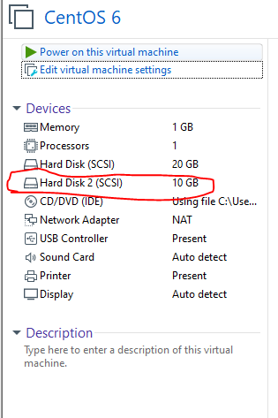

**2. Create 2 Partitions 4GB and 6GB of Space respectively.**

**1**

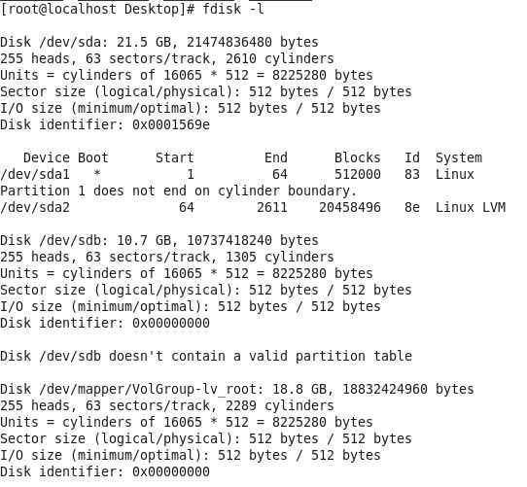

**2**

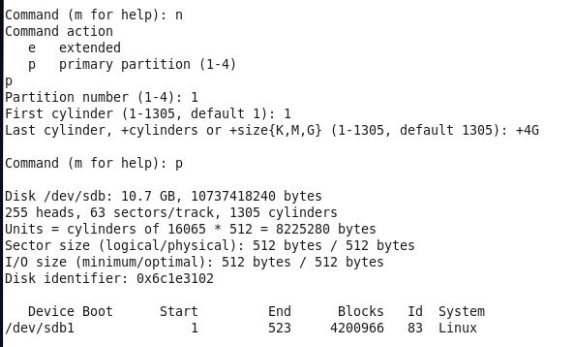

**3**

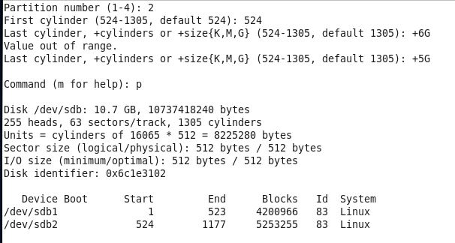

**3. Format 4GB with xfs and 6GB with ext4 file system.**

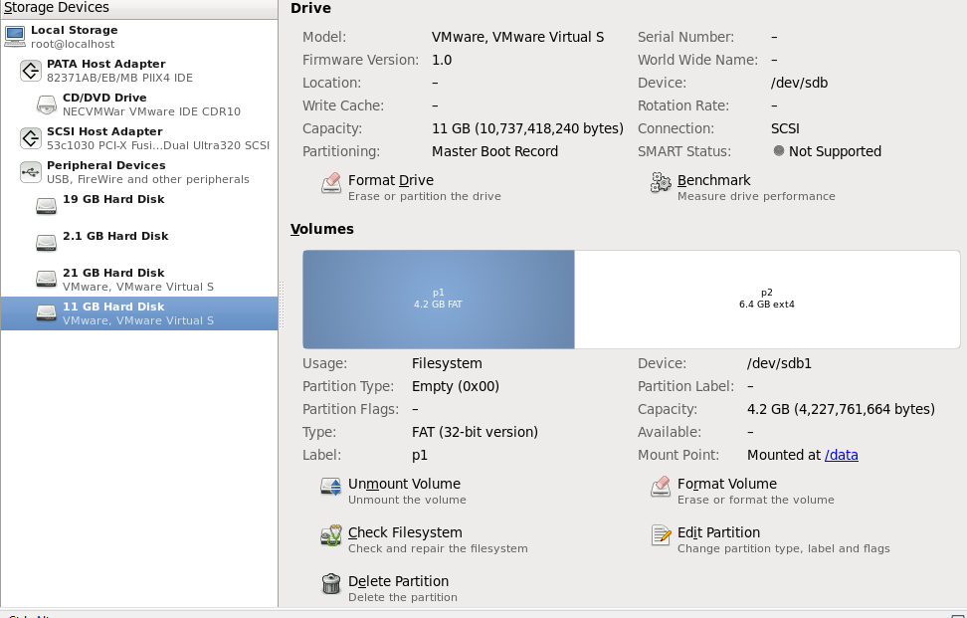

**4. Mount 4GB and 6GB in /data and /music directory respectively.**

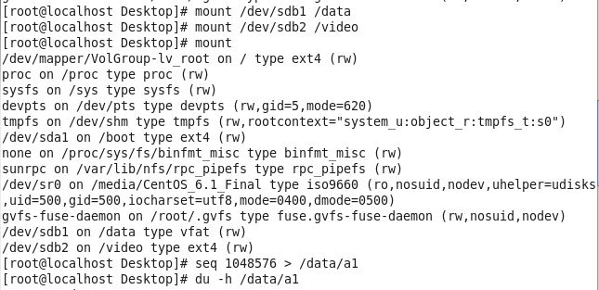

**5. Create one file of 1GB in each of the mount point created above.**

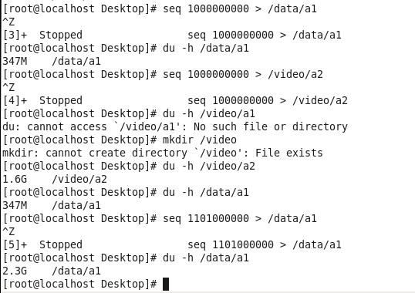

**6. Verify the disk Consumption and disk space free in the mounted partitions.**

